Module 06 Practice Project Insurance Cost Screenshot Evidence and Discussion
This document collects the screenshots for the practice project on insurance cost analysis and gives each step a heading that follows the five tasks of the notebook. The project cleans medical_insurance_dataset.csv, 2772 policy holders with seven attributes, explores how each attribute relates to the annual charges and compares single variable, multivariate, pipeline and Ridge regressions. Each screenshot file name is printed below its image.

PracticeProject_1. Step 0 Importing the libraries needed for the project
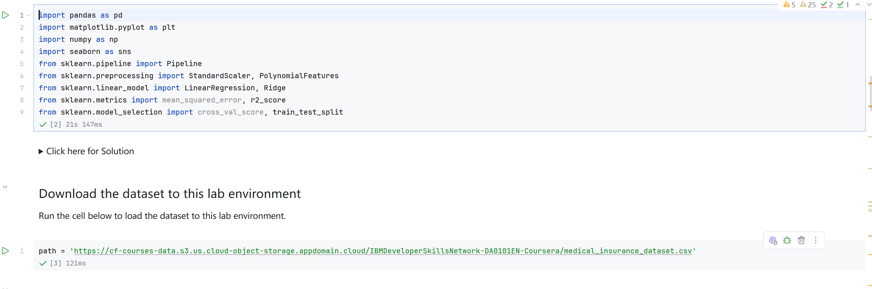
Screenshot file: 01_import_libraries.png
(image width 16.4 cm, scale to fit)
pandas, matplotlib, seaborn and the scikit learn estimators used later in the project are imported in one cell so every following step has them available.

PracticeProject_2. Task 1 Reading the dataset and printing the first ten rows
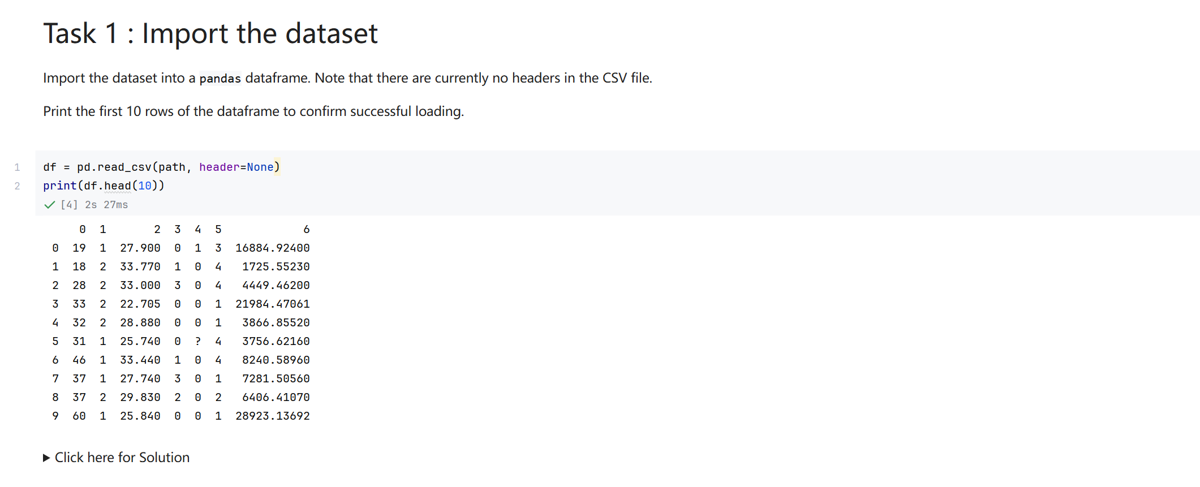
Screenshot file: 02_Task1_pd.read_csv_and_df.head_10.png
(image width 16.4 cm, scale to fit)
pd.read_csv with header=None loads the headerless file and the first ten rows confirm 2772 records with the seven documented attributes.

PracticeProject_3. Task 1 Replacing the question marks with NaN
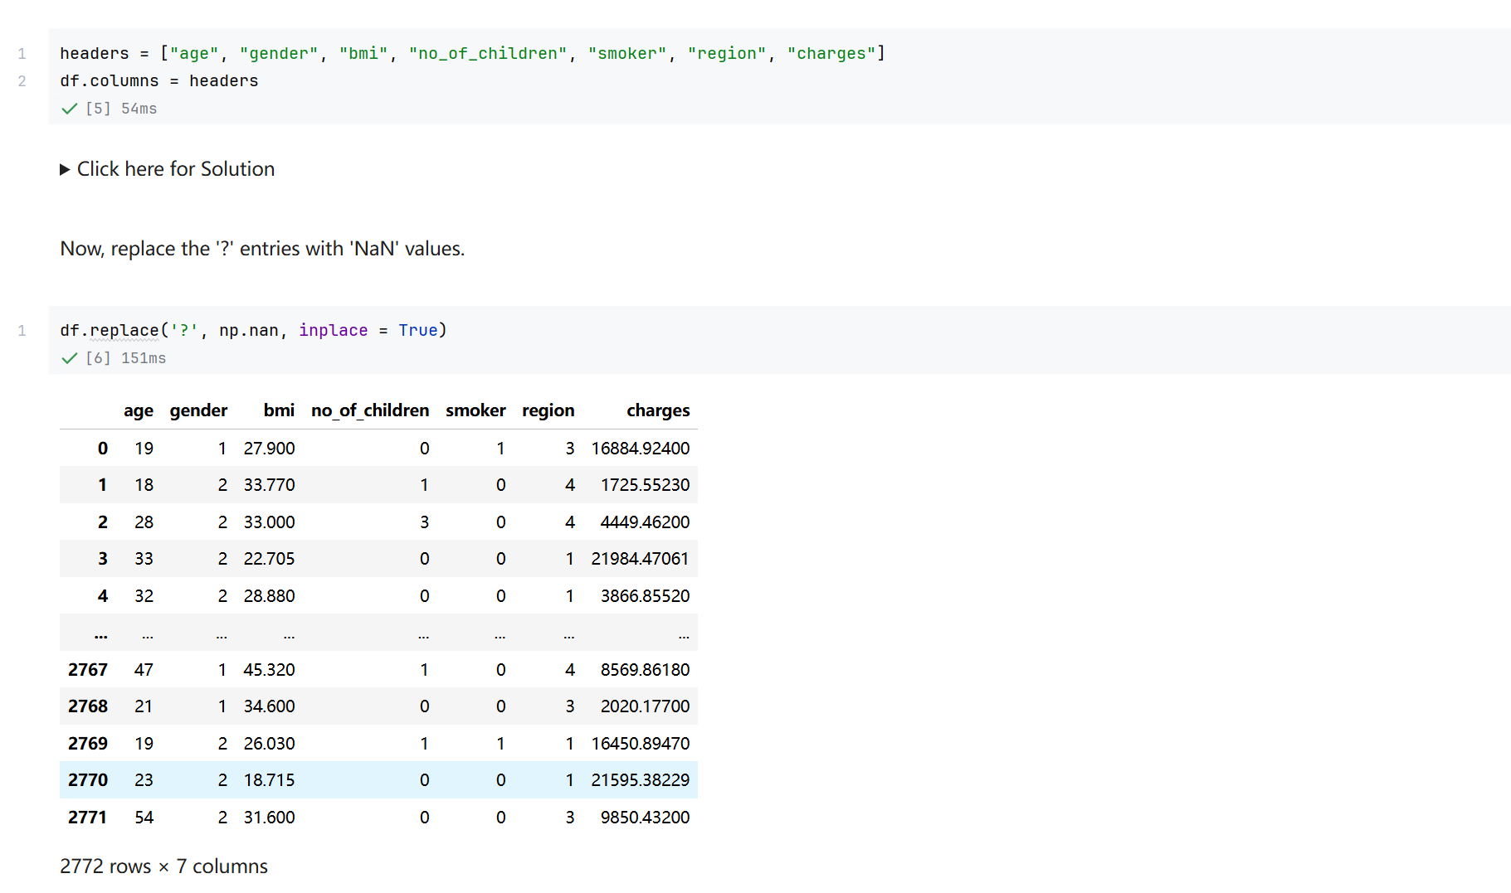
Screenshot file: 03_Task1_df.replace_question_mark_with_NaN.png
(image width 16.4 cm, scale to fit)
df.replace turns the missing value marker into a real missing value so that it can be counted and filled in the next task.

PracticeProject_4. Task 2 Locating the missing values with df.info
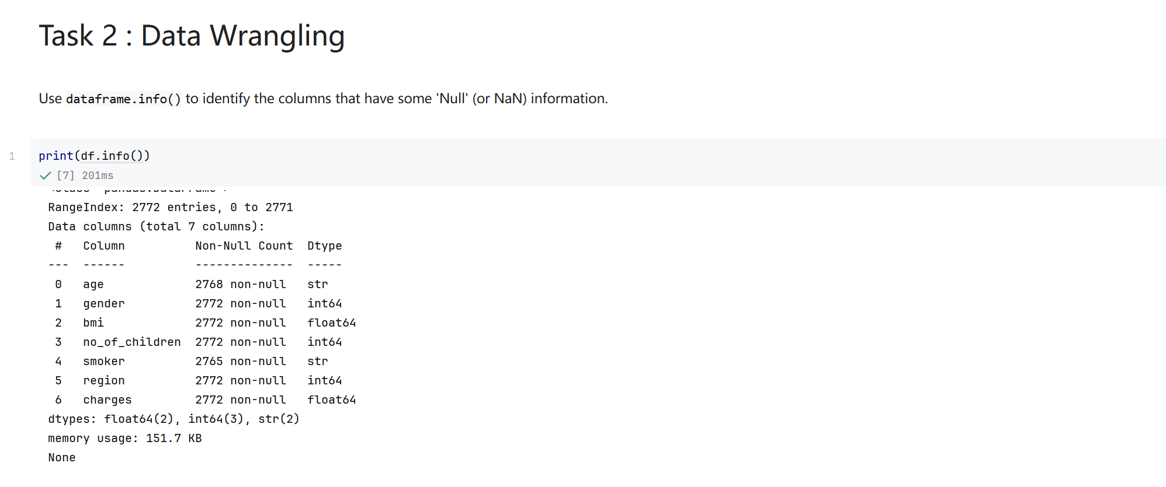
Screenshot file: 04_Task2_print_df.info.png
(image width 16.4 cm, scale to fit)
print(df.info()) shows the non null counts and identifies age, with 2768 values, and smoker, with 2765, as the only incomplete columns.

PracticeProject_5. Task 2 Filling the missing values and updating the data types
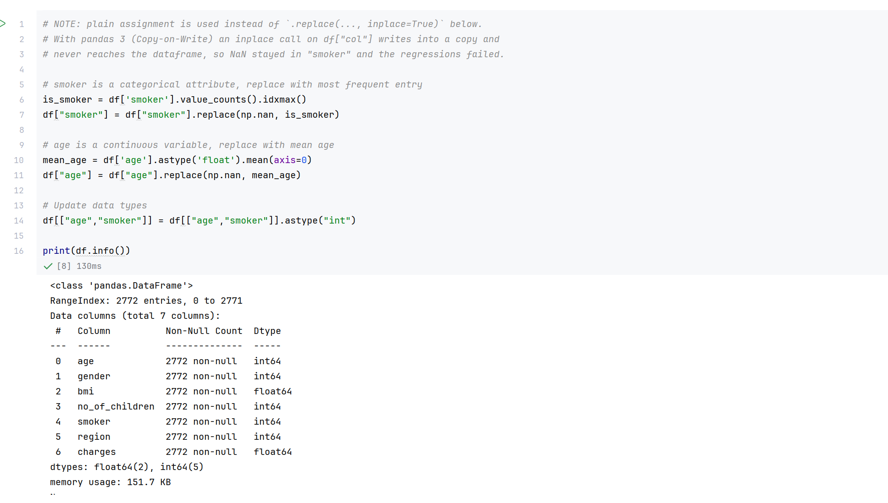
Screenshot file: 05_Task2_fill_missing_smoker_and_age.png
(image width 16.4 cm, scale to fit)
The smoker column is filled with its most frequent value and age with its mean, and both are converted to integers. The cell uses plain assignment rather than an in place call on a column, because pandas 3 copies the column and the in place version would leave the NaN in place.

PracticeProject_6. Task 2 Rounding the charges to two decimals
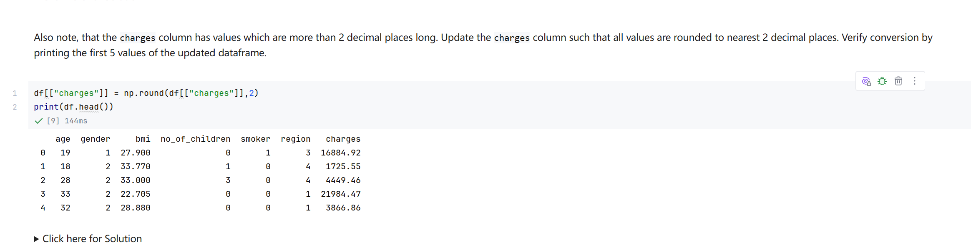
Screenshot file: 06_Task2_np.round_charges.png
(image width 16.4 cm, scale to fit)
np.round on the charges column keeps two decimal places and the first rows are printed to verify the conversion.

PracticeProject_7. Task 3 Regression plot of charges against BMI
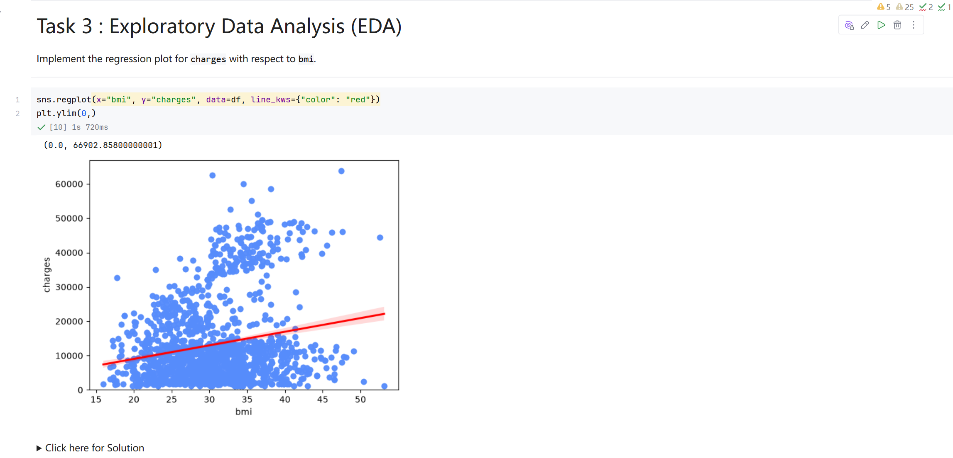
Screenshot file: 07_Task3_regplot_bmi_vs_charges.png
(image width 16.4 cm, scale to fit)
sns.regplot for bmi against charges shows a weak positive trend, with the smoker effect clearly visible in the spread of the points.

PracticeProject_8. Task 3 Box plot of charges for smokers and non smokers
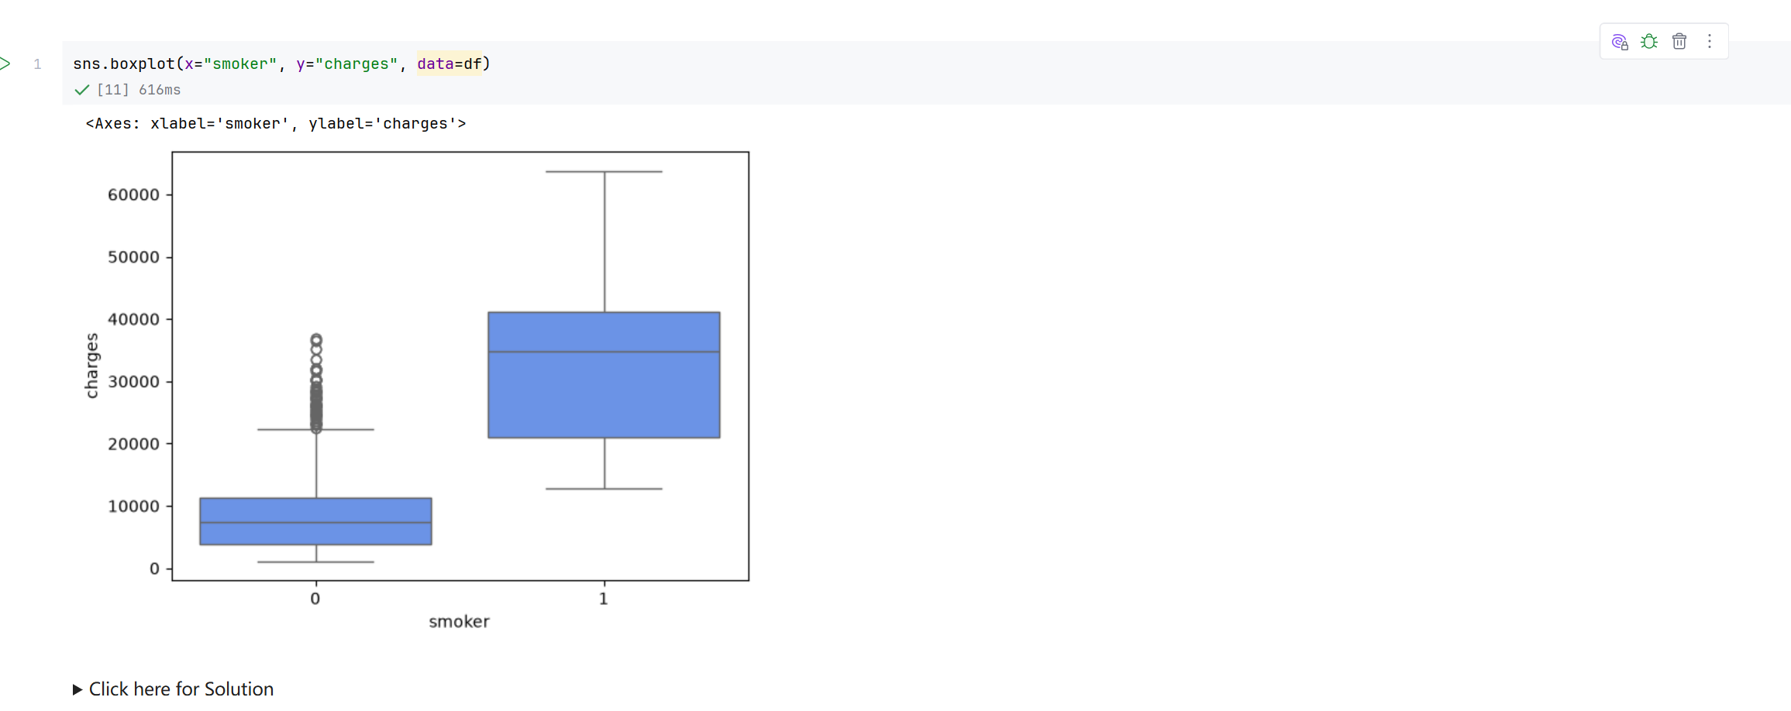
Screenshot file: 08_Task3_boxplot_smoker_vs_charges.png
(image width 16.4 cm, scale to fit)
sns.boxplot for smoker against charges shows that smokers pay markedly more, the strongest single split in the dataset.

PracticeProject_9. Task 3 Correlation matrix of the dataset
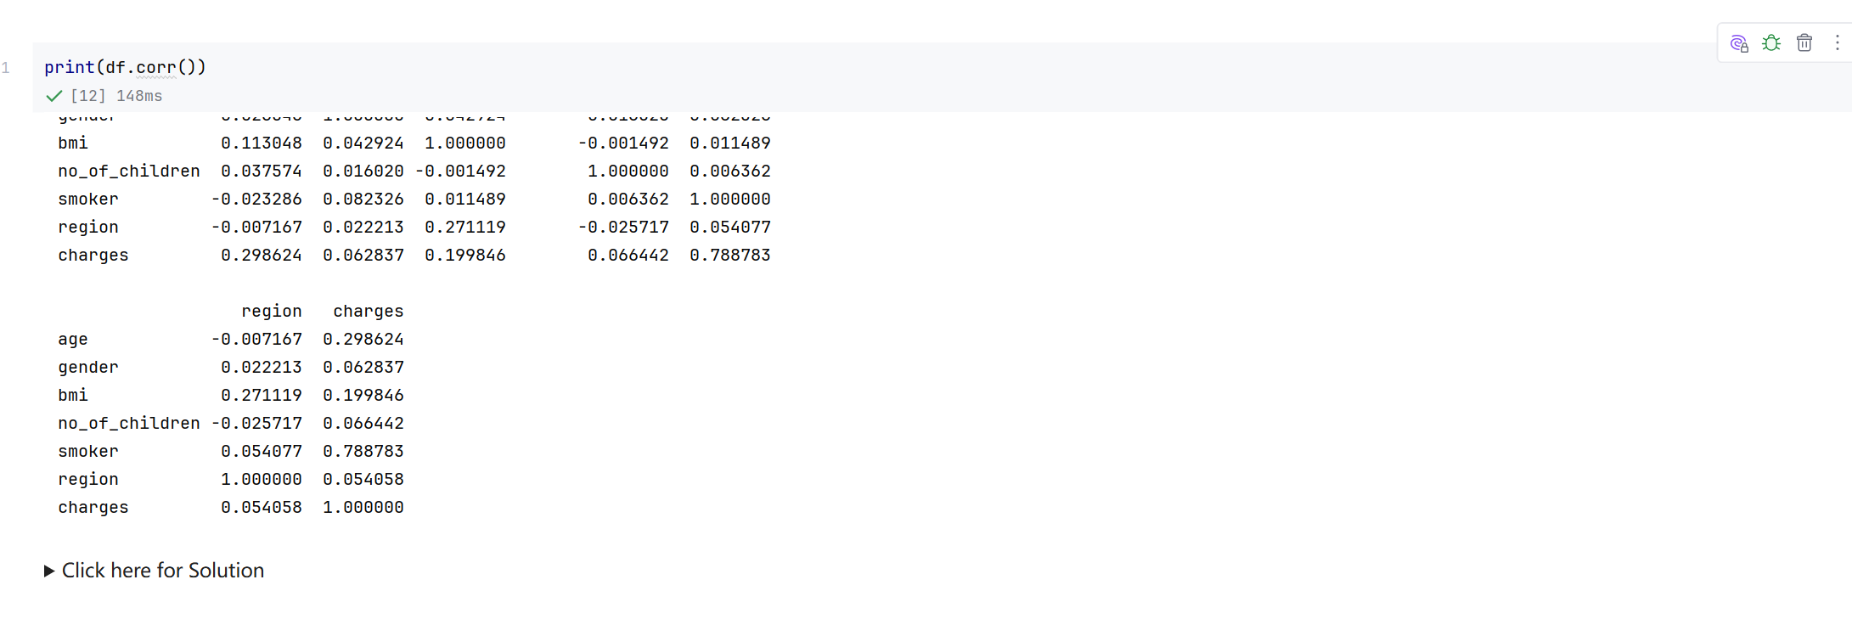
Screenshot file: 09_Task3_print_df.corr.png
(image width 16.4 cm, scale to fit)
print(df.corr()) gives the pairwise correlations; smoker correlates with charges at about 0.79, far above the other attributes.

PracticeProject_10. Task 4 Linear regression using only the smoker attribute
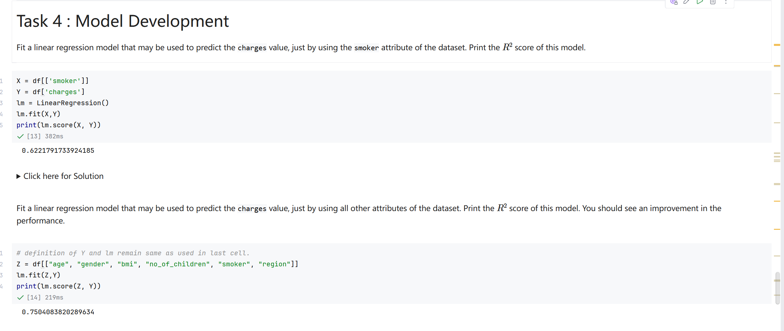
Screenshot file: 10_Task4_linear_regression_smoker_R2.png
(image width 16.4 cm, scale to fit)
The single variable model reaches an R squared of about 0.622, which quantifies how much of the charge variation the smoking status alone explains.

PracticeProject_11. Task 4 Linear regression using all other attributes
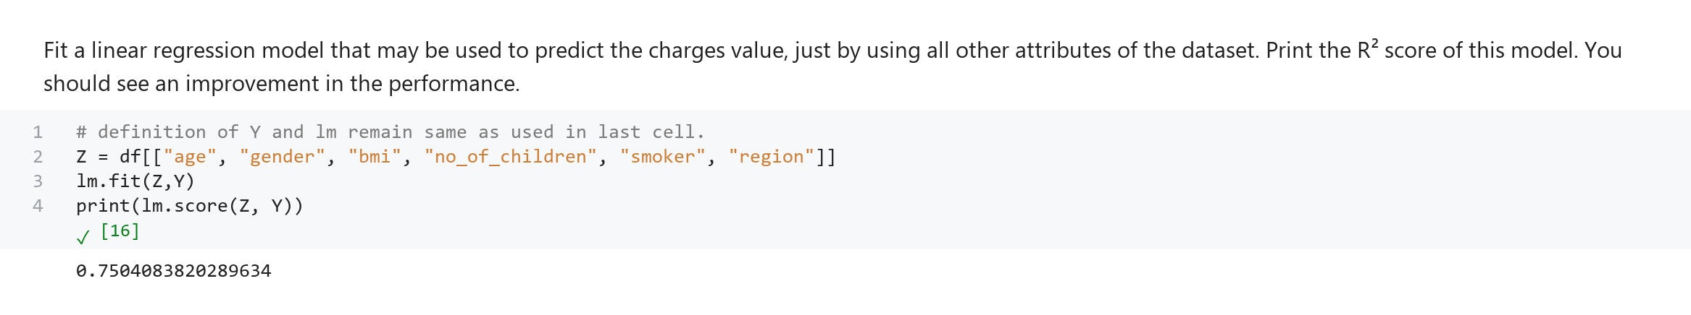
Screenshot file: 11_Task4_linear_regression_all_attributes_R2.png
(image width 16.4 cm, scale to fit)
Fitting the model on age, gender, BMI, number of children, smoker and region raises R squared to about 0.750.

PracticeProject_12. Task 4 Pipeline with scaling, polynomial features and linear regression
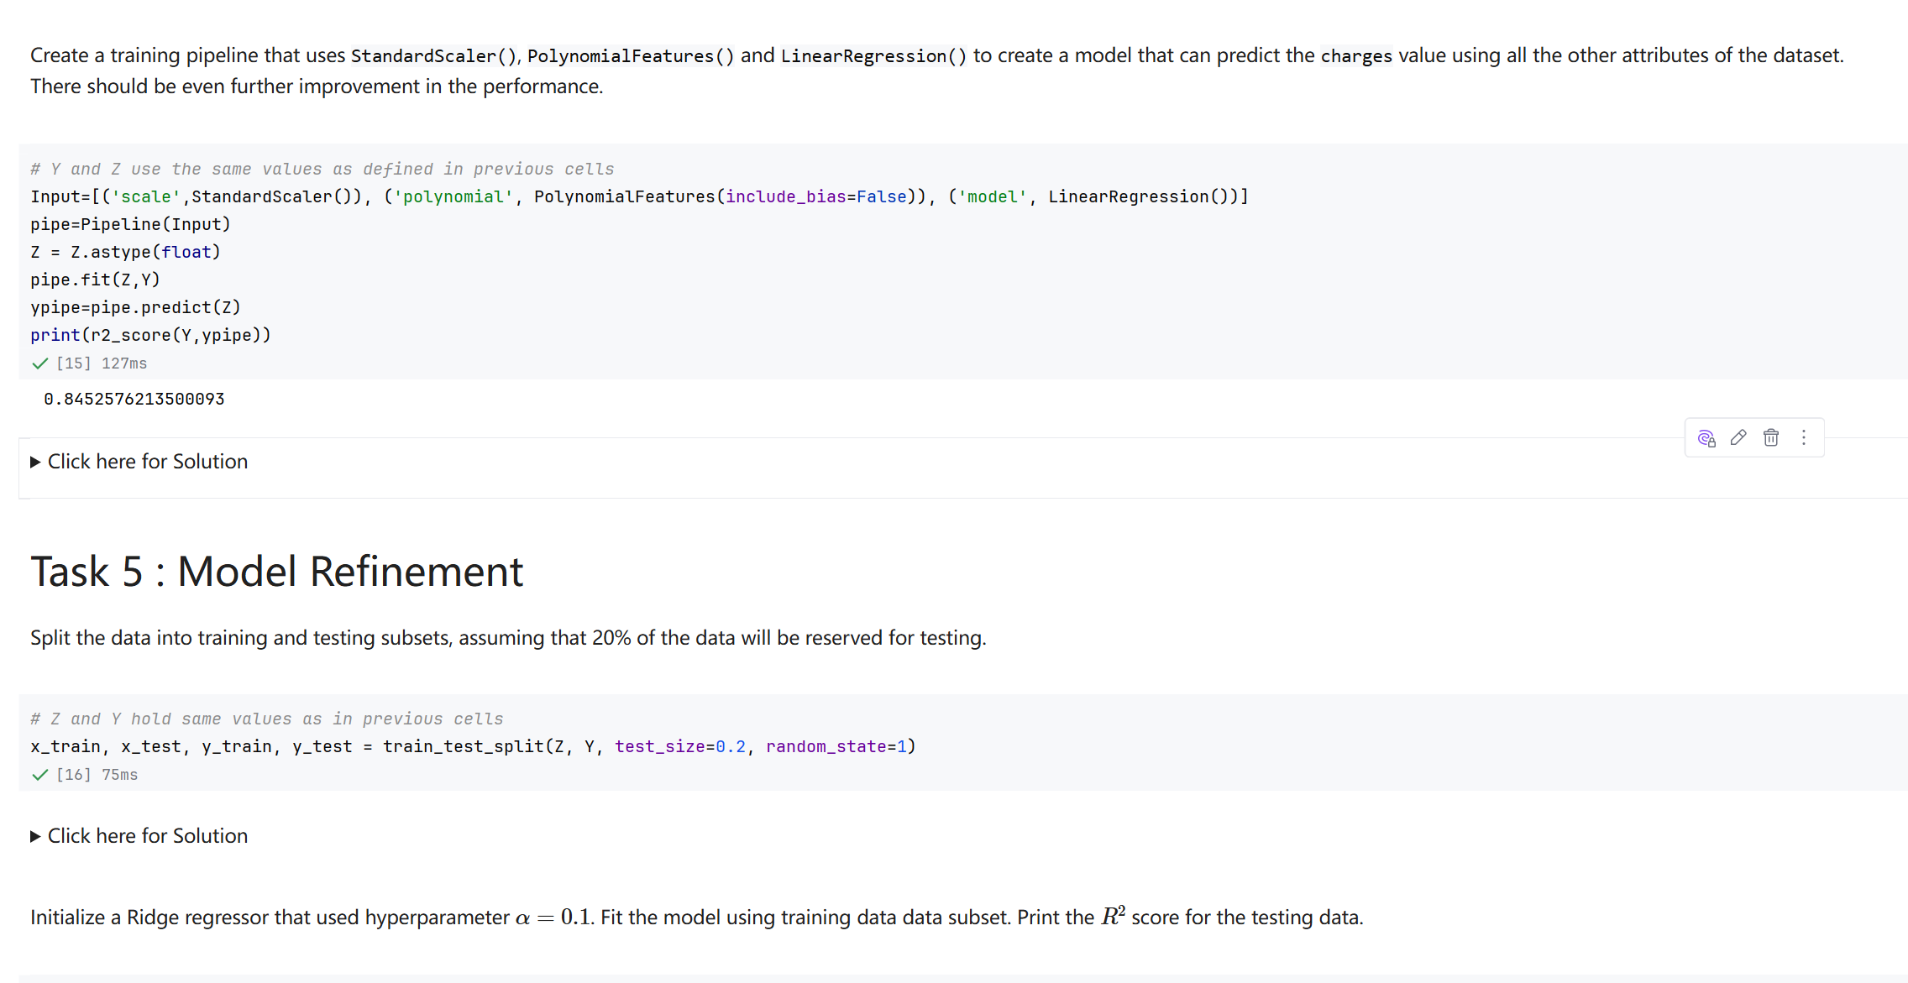
Screenshot file: 12_Task4_Pipeline_fit_score_R2&Task5_dataset.png
(image width 16.4 cm, scale to fit)
The pipeline combines standardisation, polynomial expansion and linear regression and reaches an R squared of about 0.845 on the same data.

PracticeProject_13. Task 5 Ridge regression and the polynomial Ridge model on the test set
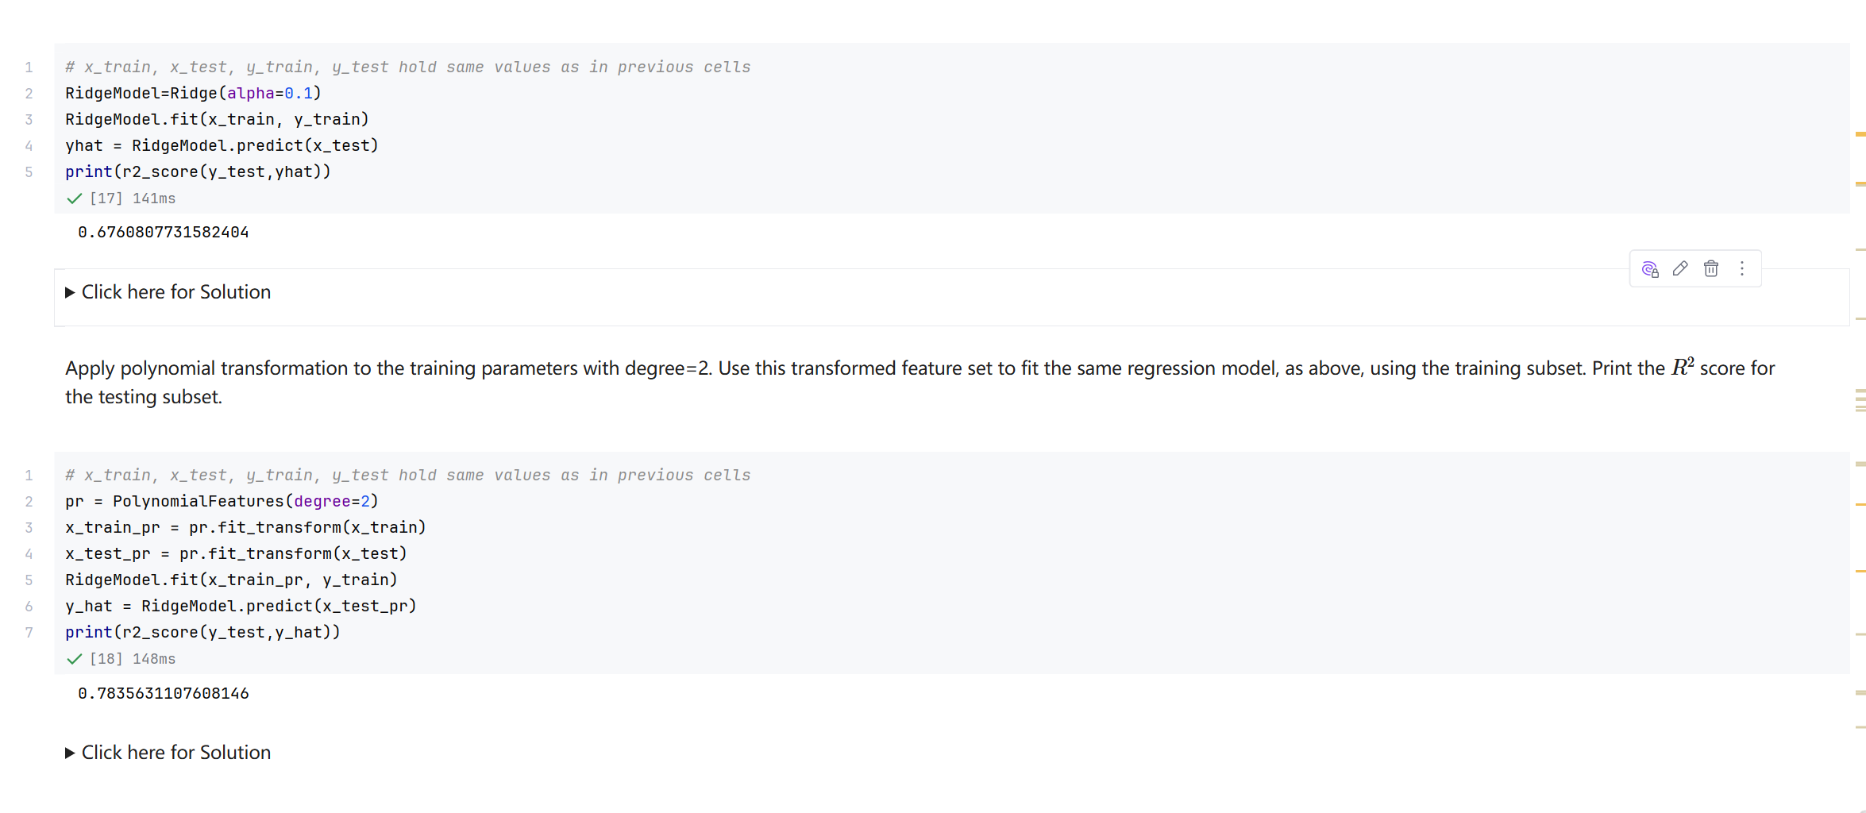
Screenshot file: 13_Task5_Ridge_alpha0.1_and_PolynomialFeatures_degree2_R2.png
(image width 16.4 cm, scale to fit)
After an 80 20 split, Ridge with alpha 0.1 scores about 0.676 on the test set and the second order polynomial version of the same model improves this to about 0.784.

